Review on the Lower III Residential at Oaker Wood Leisure
It would be an understatement to say that this was the best week of my entire life! Thankfully, the sun was shining, and we had warm weather all week.
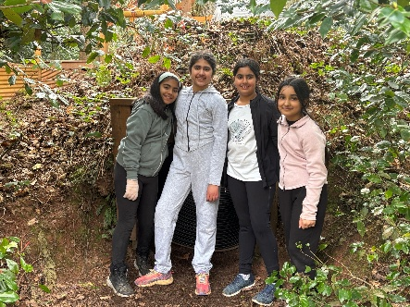
My parents waved me off on the coach, and from then on, I was ready, ready to complete every challenge, enjoy each activity and have a load of fun!
On arrival at Oaker Wood, we were sat down in the eating area and were given a set of rules. The main one was to enjoy yourself! After this, we were placed into sleeping arrangements and cabins, which we would stay in for the rest of the trip. Thankfully, everybody was put with their best friends.
Our first activity was fun team challenges in the Low Ropes Borneo Assault Course! We were divided into groups and with our Oaker Wood instructor, took on various challenges, improving our teamworking and leadership skills.
Afterwards, we played an extremely fun game called Capture the Flag! There were two different teams, the blue team and the red team, but my team won!
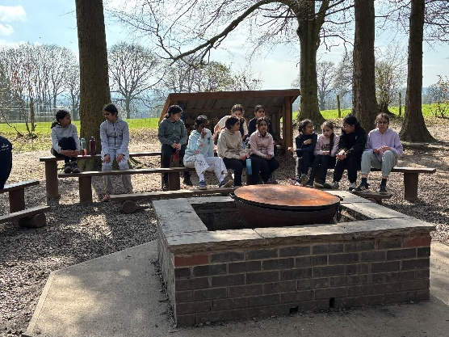
To end the day, we all sat around the campfire and toasted marshmallows. What a tiring but fun day we had!
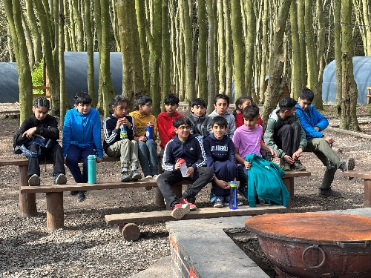
The next day, we on a nature walk, to collect stamps, which spelt out an anagrammed word, and listened to animal facts along the way.
Then, we did the High Ropes activities. They included Quick Jump, Leap of Faith and much more!
Ending the day, we sat around the lovely, warm campfire and we were given a nice, tasty cup of hot chocolate and two marshmallows to toast around the fire.
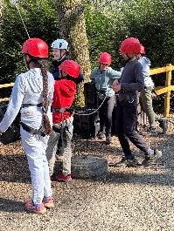
The next morning, we did Zip Lining, Crate Stacking and Team Challenges! Zip Lining was in my top five favourite activities, especially as we got a surprise visit by Mr Draper! New experiences and facing my fears meant that I left Oaker Wood with even more bravery than before I left home!
Finally, we sat around the campfire cosily at the end of the day, sipping hot chocolate!
By Thursday, we were all starting to falter, tired from our late-night conversations! We did the Woodland Krypton challenges and we all took part in a trail through the Oaker Wood forest and completed a series of activities in the Woodland Krypton! Each team had to complete the tasks that lay ahead of them, scoring points along the way. I really enjoyed myself!
Afterwards, we made our lunch! The Pizza-making activity was as fun as it was yummy! We were given a set of instructions and then, in our groups, we made a pizza dough, which transformed into a delicious lunch! On Thursday, we also got to go to the shop, which had various different items to purchase, including toy squirrels, notepads, pens, pencils, magnets, and hats!
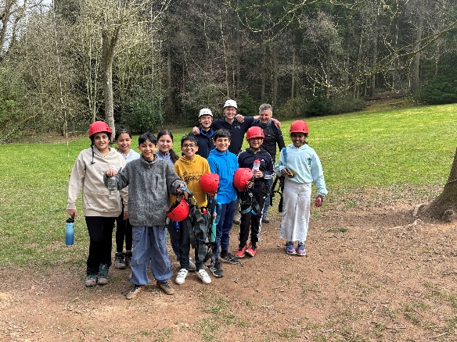
Around the campfire, we did karaoke (as it was our last night there) and Mr Tobin found his new favourite song!
On our final day, although everyone was disappointed to be leaving, we all cheered up after a superb game of Paintball! The paintball zone was the most fantastically featured section at Oaker Wood, and I loved the realistic scenarios like the car, bus, and helicopter. Luckily, we were told that the guns and paintballs were smaller, so it was less painful for us. Finally, we had to get on board the coach and say a reluctant goodbye to the instructors. Even though everybody in Lower III wished that they could stay longer on the Residential, we definitely made memories that will last for the rest of our lives.
Thank you, Mrs Crosby, Mrs Smith, and Mr Tobin, for organising an amazing trip for Lower III and an extra special thank you to all of the instructors at Oaker Wood Leisure for making this a life changing experience for us all.
By Tia Kaur Hunjan, Age 10

